LABORATORY EXERCISE 7

FILE UPLOADS (COURSE MATERIALS)

Learning Objectives
By the end of this laboratory exercise, students should be able to:
- Design and implement a database schema for managing file uploads related to courses.
- Utilize CodeIgniter's File Uploading Library to handle file uploads securely.
- Create an administrative interface for uploading and managing course materials.
- Implement access control to ensure only enrolled students can download materials.
- Enhance the user interface with Bootstrap for a clean and functional file management system.

Prerequisite student experiences and knowledge
Before starting this exercise, students should have:
- Completed Laboratory Exercise 6 (Course Enrollment System).
- A solid understanding of CodeIgniter's MVC structure and database operations.
- Experience with HTML forms and Bootstrap styling.
- Basic knowledge of handling file inputs in HTML.
- Familiarity with user authentication and session management in CodeIgniter.

Background
A core feature of any Learning Management System (LMS) is the distribution of learning resources. This involves allowing instructors to upload various file types (such as PDFs, PowerPoint presentations, and documents) and making them available to enrolled students. CodeIgniter provides a robust File Uploading Library that simplifies the process of validating, uploading, and securing files. This exercise will integrate this functionality into the LMS, ensuring that file management is seamless and secure.

Materials/Resources
- Personal Computer with Internet Access
- XAMPP/WAMP/LAMP server installed
- CodeIgniter Framework (latest version)
- Visual Studio Code or any code editor
- Git and GitHub Account
- Web Browser (Chrome, Firefox, etc.)
Laboratory Activity
Step 1: Create a Database Migration for Materials Table
- Create a new migration file for the materials table.
Run: php spark make:migration CreateMaterialsTable
- Open the newly created file in app/Database/Migrations/.
- In the up() method, define the table with the following fields:
- id (Primary Key, Auto-Increment)
- course_id (INT, Foreign Key referencing the `courses` table)
- file_name (VARCHAR(255)) to store the original filename
- file_path (VARCHAR(255)) to store the path to the uploaded file
- created_at (DATETIME)
- In the down() method, define how to drop the table.
Run the migration: php spark migrate

Step 2: Create a Model for Materials
- Navigate to app/Models/ and create a file named MaterialModel.php.
- Create a model class with methods to:
- insertMaterial($data) Insert a new material record.
- getMaterialsByCourse($course_id) Get all materials for a specific course.

Step 3: Create or Modify a Controller for Materials
- You can create a new Materials.php controller or add methods to an existing admin controller.
- Add the following methods:
- upload($course_id) Displays the file upload form and handles the file upload process.
- delete($material_id) Handles the deletion of a material record and the associated file.
- download($material_id) Handles the file download for enrolled students.

Step 4: Implement File Upload Functionality
- In the upload($course_id) method, check for a POST request.
- Load CodeIgniter's File Uploading Library and Validation Library.
- Configure the upload preferences (upload path, allowed file types, maximum file size).
- Perform the file upload. If successful, prepare data (course_id, file_name, file_path) and save it to the database using the MaterialModel.
- Set a flash message indicating success or failure and redirect back to the course management page.

Step 5: Create the File Upload View
- Create a view file.
- The view should contain a form with the enctype="multipart/form-data" attribute and a file input field.
- Style the form using Bootstrap classes.

Step 6: Display Downloadable Materials for Students
- In the student dashboard or a dedicated course view, use the MaterialModel to fetch materials for the courses the student is enrolled in.
- Create a view that lists these materials, displaying the file name and a download button/link for each.
- The download link should point to the download($material_id) method in your controller.

Step 7: Implement the Download Method
- In the download($material_id) method:
- Check if the current user is logged in and enrolled in the course associated with the material.
- Retrieve the file path from the database using the `$material_id`.
- Use CodeIgniter's download() helper function or the Response class to force the file download securely.

Step 8: Update Routes
- Update app/Config/Routes.php to include routes for the new functionalities.
$routes->get('/admin/course/(:num)/upload', 'Materials::upload/$1');
$routes->post('/admin/course/(:num)/upload', 'Materials::upload/$1');
$routes->get('/materials/delete/(:num)', 'Materials::delete/$1');
$routes->get('/materials/download/(:num)', 'Materials::download/$1');

Step 9: Test the Application
- Run the application and test the complete flow:
- Log in as an admin/instructor.
- Navigate to a course and upload a file (PDF, PPT).
- Verify the file is saved in the designated folder and a record is added to the `materials` table.
- Log in as a student enrolled in the course.
- Navigate to the course page and verify the material is listed.
- Test the download functionality.
- Test accessing the download link while not enrolled (it should be restricted).

Step 9: Push to GitHub
- Add, commit, and push your changes to your GitHub repository.

Output / Results
- Screenshot of the materials table schema from your database (phpMyAdmin or equivalent).
- Screenshots of the file upload form (admin side) and the student view showing the list of downloadable materials.
- Screenshot of the server's file system (upload directory) showing the uploaded file.
- A screenshot of the GitHub repository with the latest commit for this exercise.

QUESTIONS:
- What are the security risks associated with file uploads, and how did you mitigate them using CodeIgniter's File Uploading Library?
-File uploads in web applications present several security risks that can compromise the entire system. The main security concerns include malicious file uploads, path traversal attacks, and unauthorized access to sensitive files. Malicious users might upload executable files like PHP scripts or viruses that could execute on the server and cause damage. They could also try to upload files with dangerous names that might overwrite important system files. To mitigate these security risks, I implemented several protective measures using CodeIgniter's File Uploading Library. First, I configured strict file type validation to only allow specific file types like PDF, DOC, and PPT documents. This prevents users from uploading executable files or scripts. I also set a maximum file size limit to prevent large files that could consume server resources. The library automatically generates random filenames for uploaded files, which prevents users from guessing file locations and accessing other users' files. Additionally, I stored all uploaded files in a protected directory outside the web root, making them inaccessible through direct URL access. The system also includes proper error handling and logging to track any suspicious upload attempts.
- Explain the purpose of the enctype="multipart/form-data" attribute in the form tag for file uploads.
-The enctype="multipart/form-data" attribute is essential for file uploads because it tells the browser how to encode the form data before sending it to the server. When uploading files, the form needs to handle binary data, which is different from regular text data. Without this attribute, the browser would use the default "application/x-www-form-urlencoded" encoding, which cannot properly handle file data and would result in corrupted or lost files. The multipart/form-data encoding allows the browser to split the form data into multiple parts, with each part containing different types of data including text fields and binary file content. This encoding method preserves the original file structure and ensures that files are transmitted correctly to the server. Without this attribute, the server would not be able to properly receive and process the uploaded files, causing the upload functionality to fail completely.
- Why is it important to check if a student is enrolled in a course before allowing them to download a material? How does this enforce application security?
-Checking student enrollment before allowing material downloads is crucial for maintaining application security and protecting intellectual property. This verification ensures that only authorized students who are officially enrolled in a course can access the course materials. Without this check, any user could potentially download materials from courses they are not supposed to access, leading to unauthorized distribution of copyrighted content and violation of academic integrity. The enrollment verification works by checking the student's enrollment status in the database before processing any download request. When a student attempts to download a material, the system first verifies that the student is enrolled in the course associated with that material. If the student is not enrolled, the system denies access and redirects them with an error message. This prevents unauthorized access and ensures that course materials remain protected. Additionally, this security measure helps maintain the academic structure by ensuring that students can only access materials for courses they are actually taking, which supports proper learning progression and course management.

Output / Results
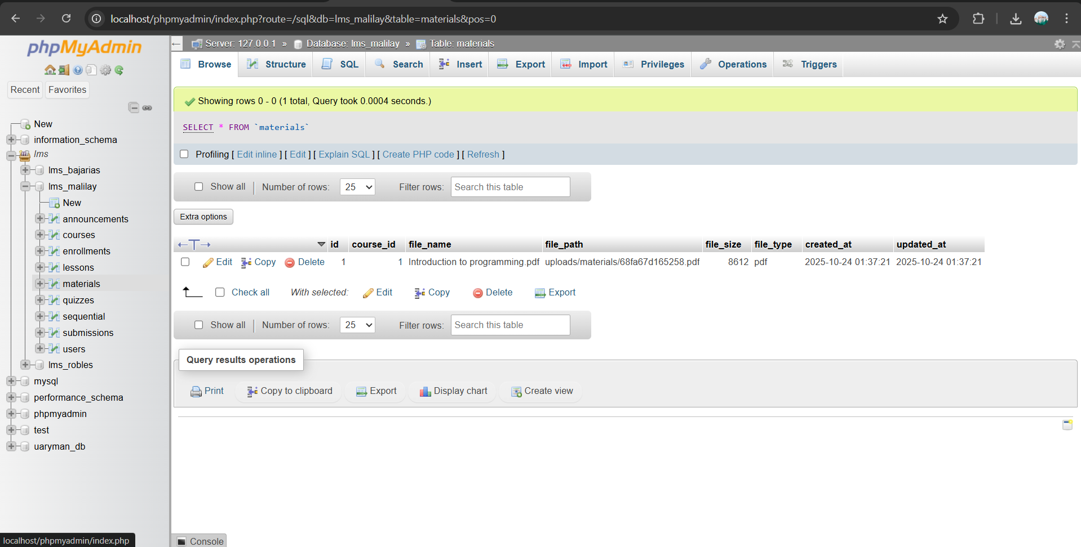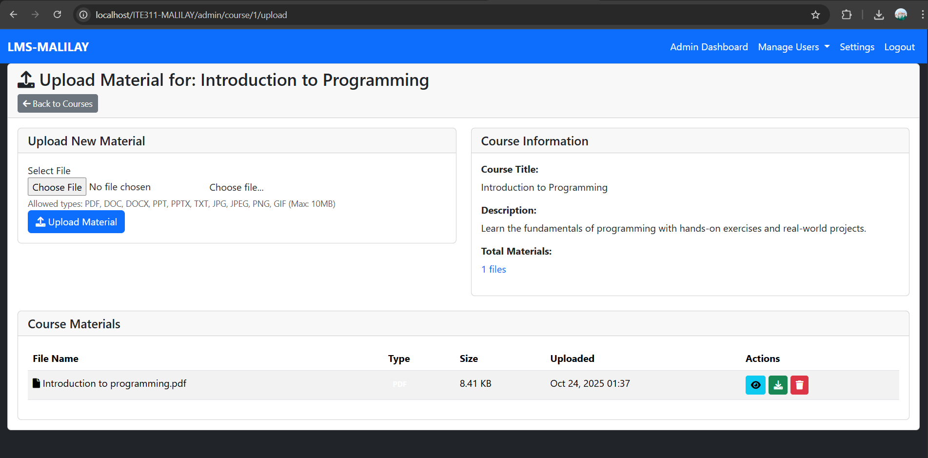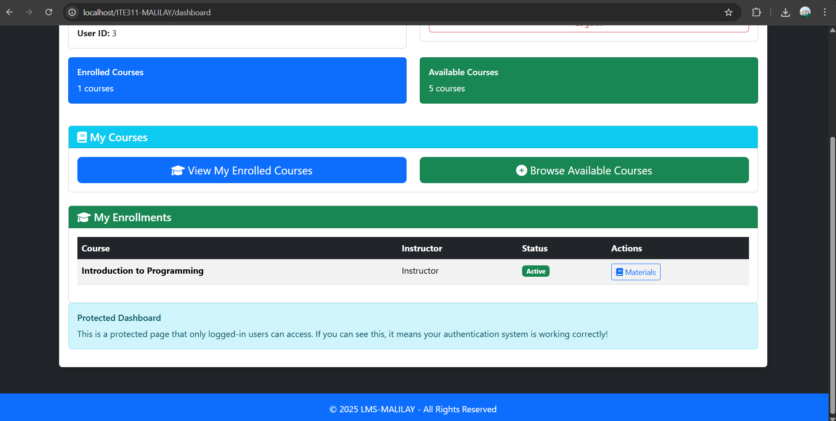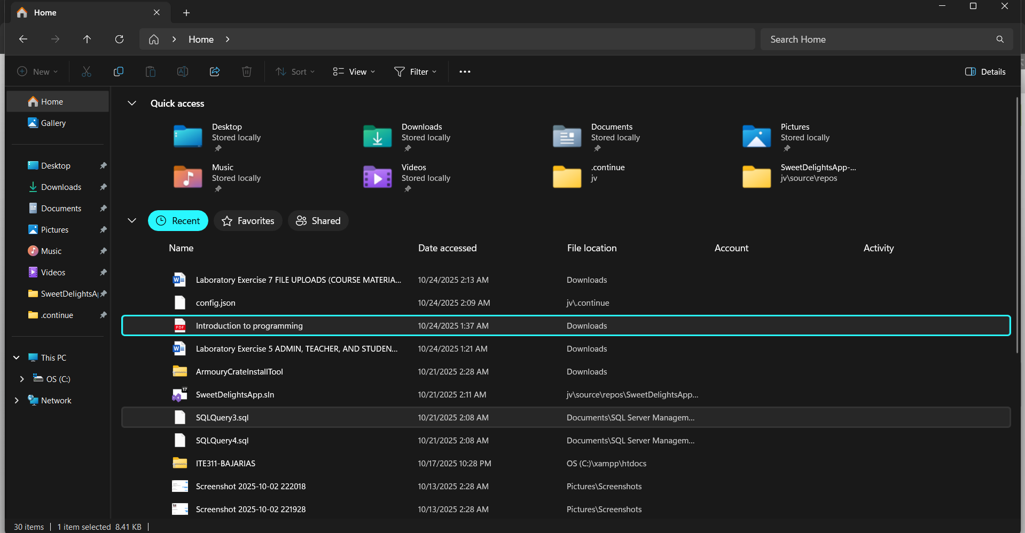

Conclusion
The file upload implementation demonstrates a comprehensive approach to web application security, addressing multiple attack vectors through CodeIgniter's built-in protections and custom validation logic. The combination of file type restrictions, size limits, secure filename generation, and access control creates multiple layers of defense against common upload vulnerabilities. The enrollment verification system ensures that educational resources remain protected while maintaining usability for authorized users. This implementation serves as a model for secure file handling in educational technology systems, balancing security requirements with functional requirements for course material distribution.

